CONTACT: Zach Brown, Liberty Hill ISD Ag Science Teacher
16500 State Route 29 Liberty Hill, Texas 78642
512-968-3972
zbrown@libertyhill.txed.net

Cassidey Weems of the Liberty Hill FFA Chapter Competes in State Prepared Public Speaking Contest

Dallas, Texas – Cassidey Weems, of the Liberty Hill FFA chapter, placed Sixth in the Texas FFA Prepared Public Speaking Contest at the 88th annual Texas FFA State Convention held July 11-15 in Dallas.

To qualify for the state competition, Weems advanced through one of 57 district competitions in the state and finished as an area winner.

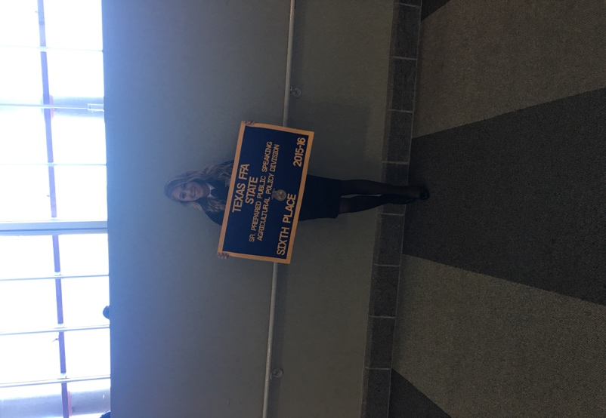
Participants prepare and present a six-to-eight minute speech about a current agricultural topic. Speakers present before a panel of judges and participate in a five-minute question-answer series designed to test the student’s knowledge of the chosen subject matter.

The 88th annual Texas FFA Convention recorded approximately 12,000 members and guests. Members of the state’s largest agricultural youth leadership organization spent the week attending leadership workshops, participating in events and activities, being recognized for their achievements, and serving as the legislative body for the Texas FFA Association.

The Texas FFA is the nation’s largest state FFA association with a membership of more than 115,000. FFA gives students the opportunity to apply practical classroom knowledge to real world experiences through local, state and national competitions. For more information about the Texas FFA, visit www.mytexasffa.org.

-30-

