CONTACT: Zach Brown, Liberty Hill ISD Ag Science Teacher
16500 State Route 29 Liberty Hill, Texas 78642
512-968-3972
zbrown@libertyhill.txed.net

Liberty Hill FFA Members Attend Texas FFA Convention in Dallas

Dallas, Texas – Members from the Liberty Hill FFA chapter attended the 88th annual Texas FFA State Convention held July 11-15 in Dallas.

Liberty Hill FFA members who attended the convention are: Rett Lee, Cassidey Weems, Katie Coldiron, Jessica Marsh, Jordan Smith, Hannah Smith, Megan Jennings, Katie Bumgardner, John Burk, Chrissa Baker, Pheonix Machanach, and Kelsee Coldiron. Also in attendance were the Liberty Hill FFA Advisors Mr. Zach Brown and Ms. Jaycee Thompson.
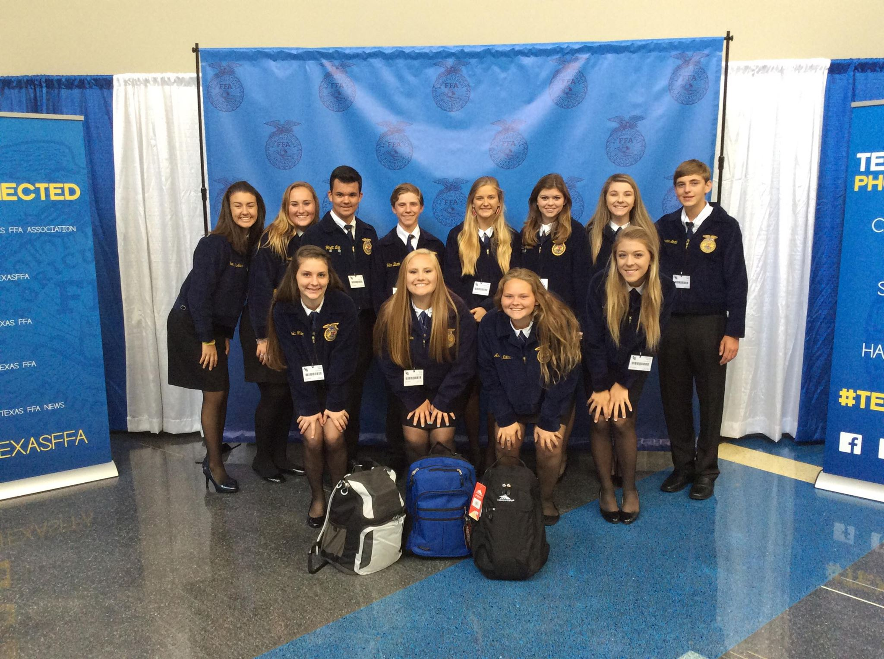
Liberty Hill participated in many activities, workshops, and opportunities at the Texas FFA Convention including members raising and donating $200 to the Dallas Police Department for the families who lost their loved ones in the terrible event the week prior to Convention. Members donated $200 and wore wristbands that said Dallas PD & Texas FFA are #allinittogether. Students of LHISD also participated in the Texas FFA Backpack Initiative where chapters brought backpacks full of school supplies to be donated to local Dallas students. All in all, Texas FFA raised over $13,000 for Dallas PD and brought over 1,400 backpacks for local Dallas Students.

More than $2 million in scholarships were awarded to FFA members and more than 2,500 members received the Lone Star FFA Degree, the highest degree of active membership bestowed by a state FFA association. More than 2,000 members were recognized on stage for their accomplishments.

Members also competed for state titles in public speaking and agriscience events. In the interest of premier leadership, personal growth, and career success, the Texas FFA Association also offered an opportunity for students to compete in the fourth annual Spanish Creed Speaking Invitational Event. The Creed delivery and the five-minute question-answer period were conducted entirely in Spanish.

Members heard from Rick Rigsby and Texas Education Commissioner Mike Morath. The Randy Rodgers Band, Texas country music artist, also performed exclusively for FFA members.

The 88th annual Texas FFA Convention recorded approximately 12,000 members and guests. Members of the state’s largest agricultural youth leadership organization spent the week attending leadership workshops, participating in events and activities, being recognized for their achievements, and serving as the legislative body for the Texas FFA Association.

The Texas FFA is the nation’s largest state FFA association with a membership of more than 115,000. FFA gives students the opportunity to apply practical classroom knowledge to real world experiences through local, state and national competitions. For more information about the Texas FFA, visit www.mytexasffa.org.

-30-

